WORLD DISTANCE AWARD (WDA)

- WDA Mission Statement
  - The objective of the WDA program is to encourage cross-country soaring by recognizing a wide spectrum of cross-country soaring pilots throughout their soaring careers.

2.0 General
2.1 The program operates on the honor system and thus does not employ the same level of documentation required for FAI badges.
2.2 Achievements in the WDA program are not numbered.
2.3 The WDA program commenced January 1, 1992.
2.4 The WDA recognizes a series of flights totaling a distance of 40,000 km representing the circumference of Earth.
2.5 Total distance accumulations of 5,000 km, 10,000 km, 20,000 km and 40,000 km are recognized with milestone Certificates and the pilot's name published in SOARING.
2.6 The 40,000 km cumulative distance is recognized with a distinctive attachment to the
pilot’s Silver, Gold, or Diamond badge.
2.7 Flight recording devices and/or turnpoint photos are optional.
2.8 For multi-place sailplanes, only the pilot in command can claim WDA distance.
2.9 Both pure gliders and powered gliders are part of this program without distinction.

3.0 Performance
3.1 Minimum WDA distance per flight is 50 kilometers.
3.2 The following table lists distance adjustment for altitude loss from start to finish as a function of maximum L/D.
Sailplane Maximum L/D | Distance Adjustment per 1000 Feet of Altitude Lost from Start to Finish
L/D ≤ 25 | 3 km (1.86 st mi)
25 < L/D ≤ 35 | 6 km (3.73 st mi)
35 < L/D ≤ 50 | 12 km (7.45 st mi)
50 < L/D | 16 km (9.94 st mi)

    - There is no distance adjustment if the finish altitude equals or exceeds the start
altitude.
    - Altitude loss is rounded to the nearest 1000 feet; e.g., a 499 foot tow/engine climb above finish altitude incurs no altitude deduction.
    - For each 1000 feet of altitude lost from start to finish, subtract the distance adjustment from the actual flight distance flown. The adjusted distance must still equal or exceed the 50 kilometer minimum.
3.3 Each flight must begin with a launch/take off from the ground.
3.4 Distance tasks, turn points and start/finish altitudes are determined by the pilot.
3.4.1 Start altitude may be a defined Start Line or tow release/engine shutdown altitude.
3.4.2 Finish altitude may be a defined Finish Line or landing/first engine restart altitude.

4.0 Administration
4.1 The pilot of a WDA flight must be an SSA member at the time of each flight.
4.2 WDA flights must be entered in the pilot’s logbook.

4.3 WDA flight distances may be accumulated but each flight submitted to the WDA administrator must be no more than one year old.
4.3.1 The WDA distances submitted must be signed by an SSA member who is satisfied that logbook entries exist for the flight distances claimed.
4.3.2 WDA one-time registration fees are set by the SSA and must be paid by the time the first WDA flight distances are submitted.
4.4 The WDA Administrator maintains a record of each participant’s distances until completion of 40,000 km.
4.5 The WDA Administrator provides summaries to the SSA Badge Person for publication in SOARING.
4.6 The NSM is the repository of the archival WDA data.
4.7 Upon completion of 40,000 km, SSA provides the WDA attachment (Paragraph 2.6) at nominal cost.
4.7.1 World Distance Award. See photograph showing the WDA attachment
mounted on a badge.

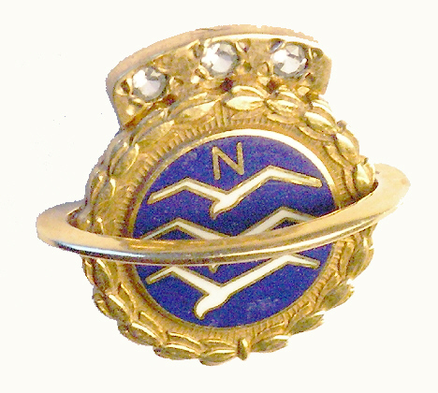

revised: April 1, 2005

Revision 1 Dated: April 1, 2005 Delete paragraph 4.2.1

